GIT & GITHUB

What Is Source Control ?
Source control, also known as version control, is the practice of tracking and managing changes to software code, version control systems are software tools that help software teams manage changes to source code over time, as development environments have accelerated, version control systems help software teams work faster and smarter

Source Control Pros

Complete long-term change history of every file
Branching and merging
Traceability by linking the code with project management and bug tracking software such as Jira

Source Control Tools



What Is Git ?

Git is a free and open-source distributed version control system designed to handle everything from small to very large projects with speed and efficiency
Git developed by Linus Torvalds in 2005

Why Git ?!

High Performance
Secure
Flexible
Fast
Historical Backup
Team Based Development
Command line
Trunk based development

Git Isn’t GitHub

GitHub is a web-based Git repository hosting service, which offers all the distributed version control and source code management (SCM) functionality of Git as well as adding its own features

Fork
Project test

Let’s start with GIT

1/ download GIT https://git-scm.com/downloads/win
2/ install git
3/ try GIT GUI {graphic user interface}
4/ open GIT
5/ config username and email

$ git config --global user.name “….”
$ git config --global user.email “….”

6/ check user name and email are right

$ git config user.name
$ git config user.email

7/ another way to check name and email are right

$ git config --list

8/ get know all GIT command

$ GIT

9/ clear terminal

$ clear

repository

1/ local : in your device or machine
2/ remote : in another server or like cloud server, gitlap or github

* How to create repository

$ git init "myproject"

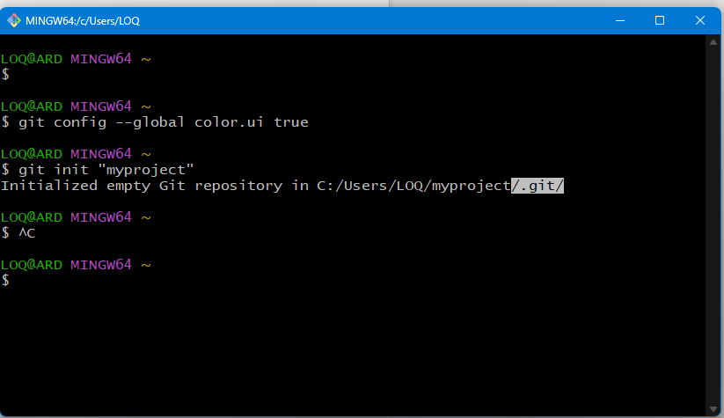

* how to see all directors of my repository

$ ls
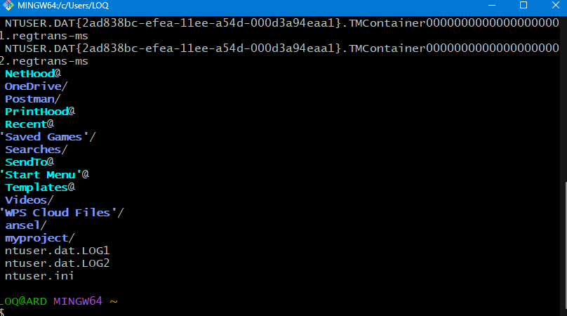

* how to get in that project

$ cd myproject

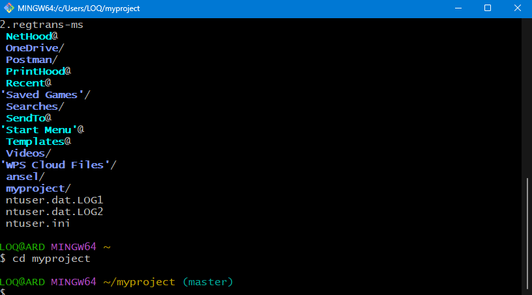

* how to open .get hidden file

$ ls-a

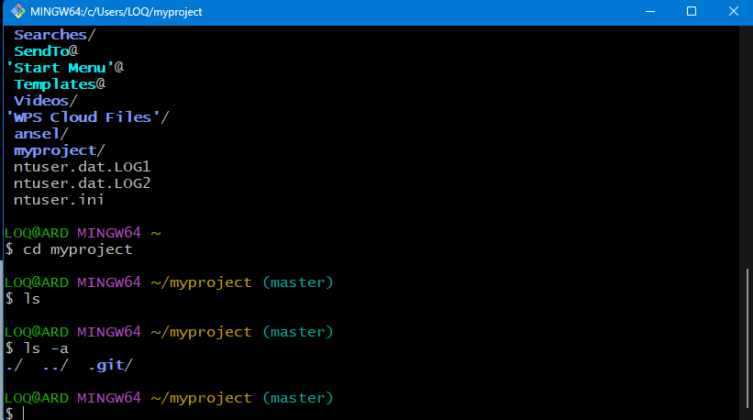

* how to know status of repository

$ git status

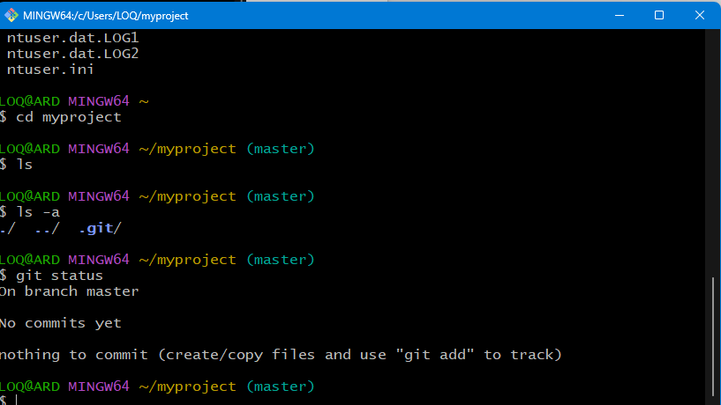

* how to create file in repository

$ touch index.html

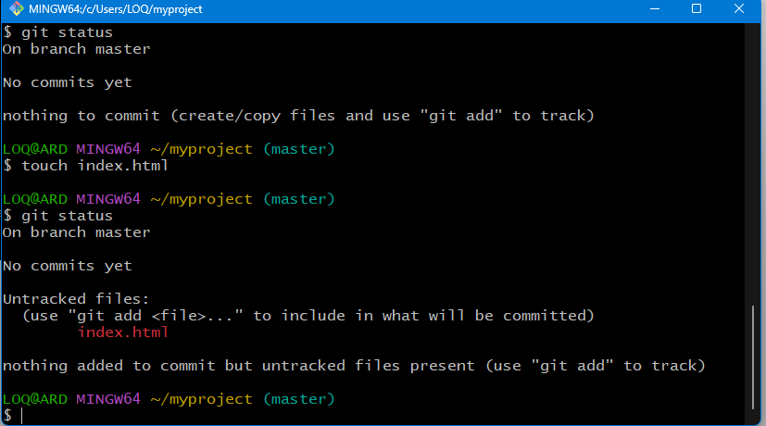

* add file to stage

$ git add index.html

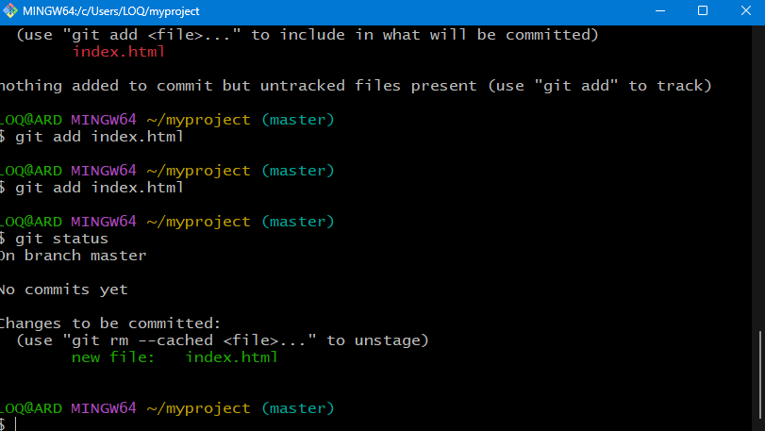

* how to create commit

$ git commit -m”create index.html”

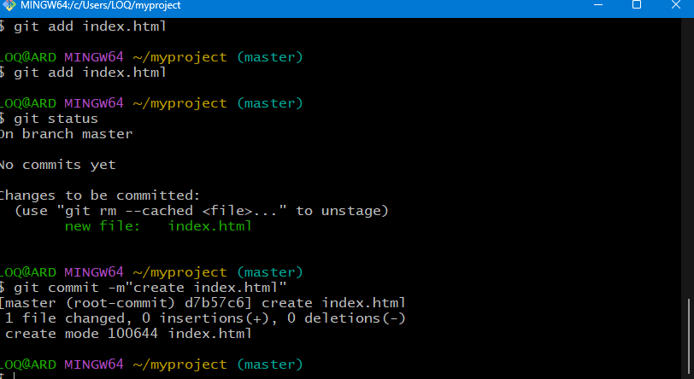

* how to changes

$ git log

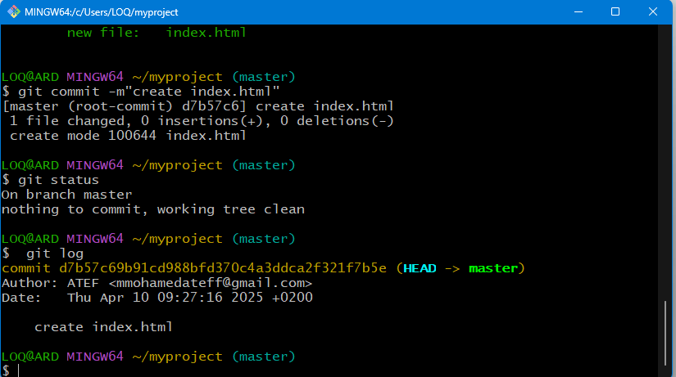

Example :
creatre javascript and css file and open it by VS using previous commands

* get back one step

$ git checkout ‘commit hash id’

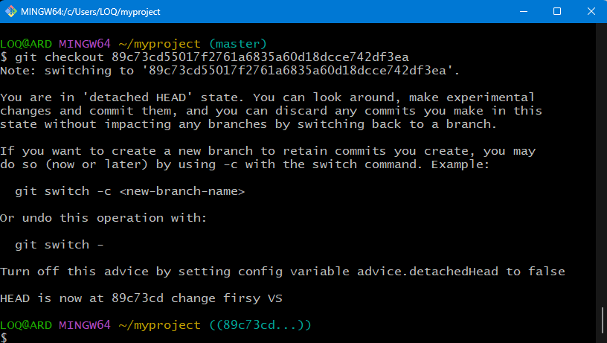

* $ git branch

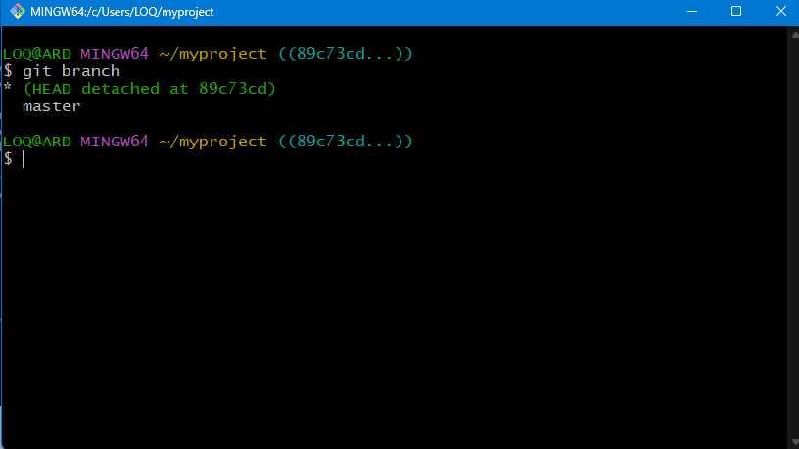

* create new branch

$ git branch atef

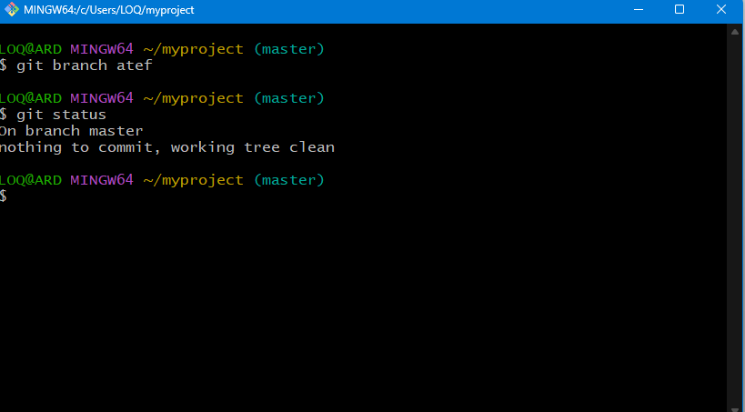

* select new branch

$ git checkout atef

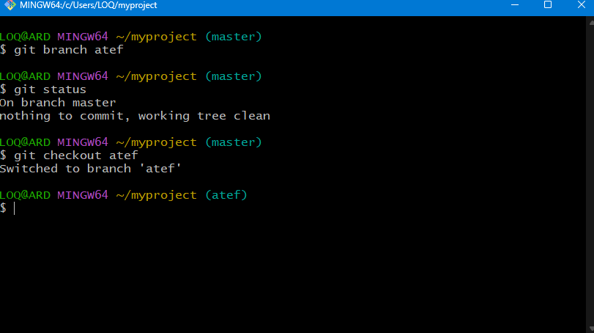

* access master branch

$ git checkout master

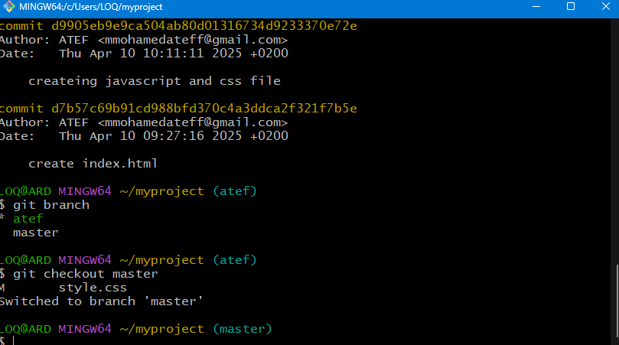

* merge branch with master

$ git merge atef

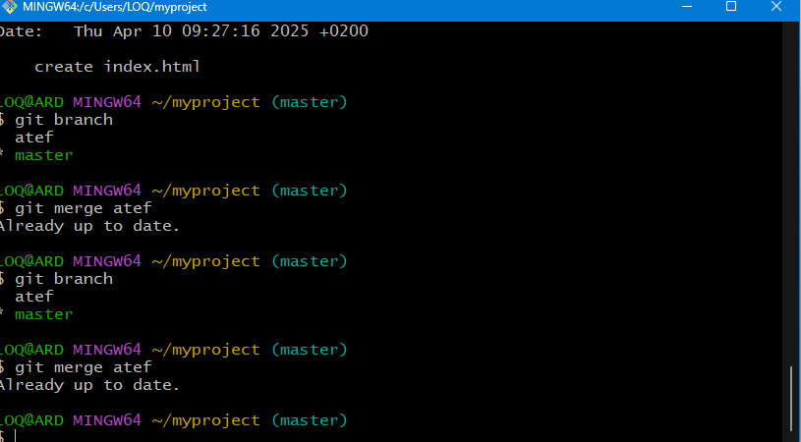

GITHUB

1/ create account on GITHUB
2/ setup your profile
3/ create new repo
4/ copy HTTPS code
5/ open GIT
6/ check connection between local and remote server

$ git remote add origin (https link)
$ gir remote -v

